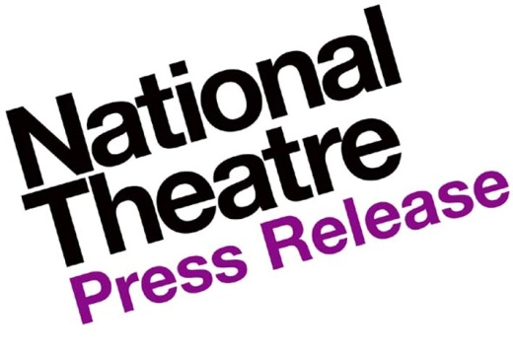

National Theatre Board begins search for new Chair as John Makinson announces he will step down in 2016
John Makinson announces today that he is to step down as Chairman of the National Theatre in 2016. He joined the NT Board in 2008 and succeeded Sir Hayden Phillips as Chairman in 2010.
The Board will now begin the formal process of appointing a new Chair; the position will be advertised next week and we expect the new appointment to be taken up next summer.
John Makinson says: ‘It will be hard to say farewell to the National Theatre but, having seen the ambitious NT Future renovation project through to a successful conclusion, I know the time is right. By the time I step down next summer I will have served eight years on the NT’s Board, most of it in the privileged role of Chairman. The new and brilliant leadership of Rufus Norris and Lisa Burger should now share the NT adventure with a new Chair, and I have no doubt that my successor will find the role as stimulating, varied and consistently enjoyable as I have.’
John Makinson is Chairman of Penguin Random House, having previously been the Chairman and CEO of the Penguin Group. He was the Finance Director of Pearson, Penguin’s parent company, between 1996 and 2002. From 1994 to 1996 he was the managing director of the Financial Times where he was responsible for the production, distribution and marketing of the newspaper worldwide. He moved to the Financial Times from Makinson Cowell, the firm that he co-founded and ran from 1989 to 1994.
26 November 2015

For further information please contact Lucinda Morrison on lmorrison@nationaltheatre.org.uk

